EENG 385 - Electronic Devices and Circuits

Lab 4 – Pseudo Ramp Generator

Lab Handout

# Objective

The objective of this lab is analyze the pseudo ramp generator and review how you will start soldering together the BJT curve tracer.

# System Architecture

Today we will explore the Pseudo Ramp Generator, a circuit that generates a ramp-shaped voltage waveform shown in Figure 1. Notice that the inclined portion of the voltage waveform, the ramp, is slightly curved. It is this slight curve, a deviation from a straight line, that puts the “Pseudo” in Pseudo Ramp Generator.

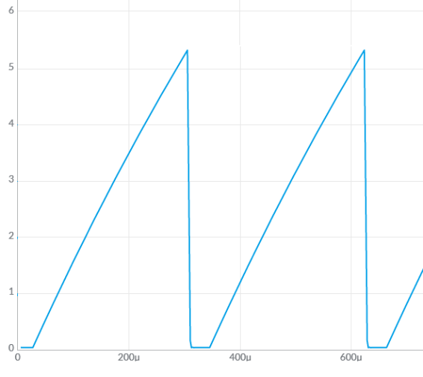

Figure 1: An example of the output that the Pseudo Ramp Generator creates.

We are now in our third lab analyzing, modeling and constructing the various subsystems that make-up the BJT Curve Tracer shown in Figure 2.

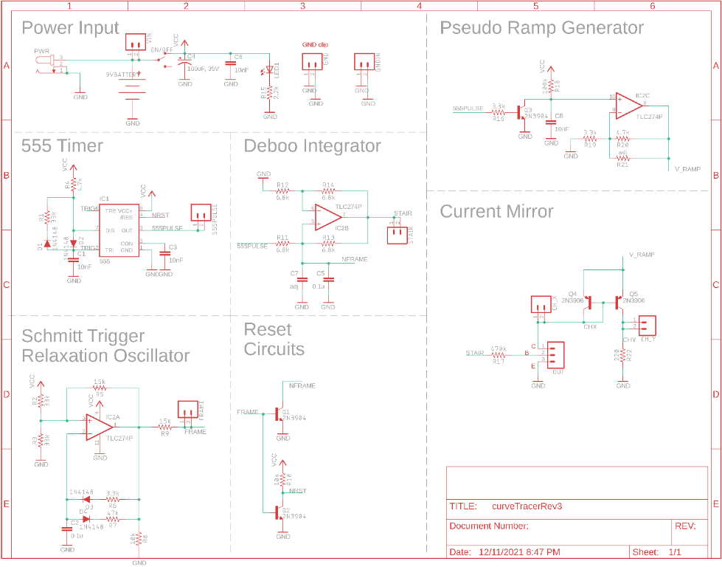

Figure 2: The complete BJT curve tracer.

Look carefully at the schematic shown in Figure 2 and located the Pseudo Ramp Generator subsystem. Now notice that this subsystem is driven by the 555PULSE signal that originates in the 555 Timer subsystem. In order to understand the behavior of the Pseudo Ramp Generator, retrieve the simulation information you found in the 555 Timer lab and put it into Table 1.

Table 1: The output of the 555 Timer simulations from the prior two labs.

|  |  |
| --- | --- |
| Quantity | 555 Timer Simulation |
| Time high (us) |  |
| Time low (us) |  |
| Period (us) |  |
| Frequency (kHz) |  |
| Duty Cycle |  |

We will come back to this table through the course of the lab.

# Analysis Pseudo Ramp Generator

When plotted as a function of time, a ramp function has a constant slope measured as $\frac{∆V}{∆t}$. The term “Pseudo” is introduced into the name because the circuit that we will build, shown in Figure 3, does not have a constant slope, it changes slightly as shown in Figure 1. To understand this further, let’s start our analysis of this circuit.

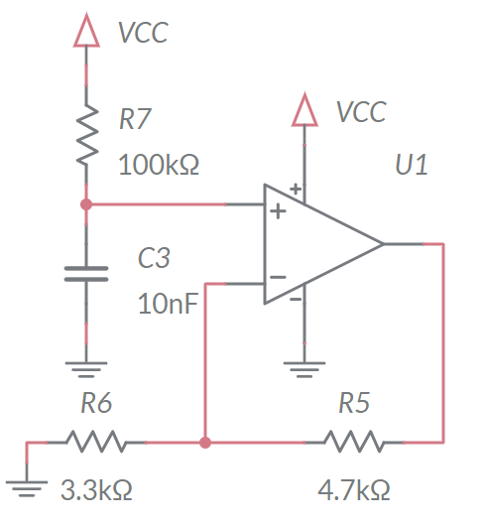

Figure 3: The Pseudo Ramp Generator circuit.

We start our analysis by recognizing that the op amp configuration in Figure 3 is a non-inverting configuration. The resistors R5 and R6 form the feedback network.

1. Determine the gain of the non-inverting op amp in Figure 3.

The voltage source of the non-inverting configuration comes from the RC circuit on the non-inverting input of the op amp.

1. Determine the time constant for the RC network on the non-inverting input of the op amp in Figure 3.
2. Write an equation describing the voltage of the charging capacitor. Assume that VCC = 9V.

So the output of the op amp in Figure 3 is the familiar exponential charging of an RC circuit. But how on earth will this be used to generate a ramp shape shown in Figure 1? Well, if we limit the charging to the very beginning of the exponential function, then we may get a sufficiently straight line to approximate a straight line. In order to do this, we will need to limit the charging of the capacitor in Figure 3. We will do this by periodically removing the charge off the capacitor using the same technique used in the Deboo Integrator.

# Analysis Pseudo Ramp Generator in BJT Curve Tracer

The Pseudo Ramp Generator will use a BJT to periodically remove the charge off the 10nF capacitor. The left-side of Figure 4 shows the schematic view of the transistor and capacitor from Figure 2.

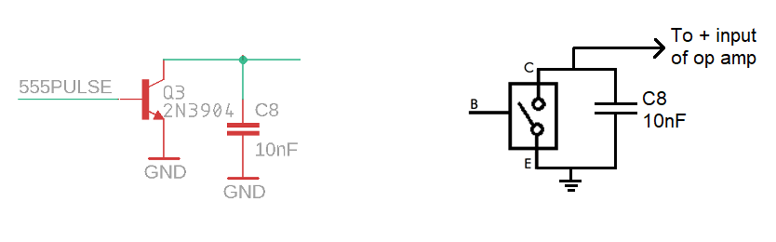

Figure 4: The schematic of a transistor/capacitor and its equivalent circuit, for the Pseudo Ramp Generator.

We will reset the charge on the Pseudo Ramp Generator’s 10nF capacitor, using the transistor Q3 as a voltage-controlled switch, shown on the right-side of Figure 4. The behavior of this switch is the same as the previous lab, and given by:

* When the base is driven towards 9V, the switch is closed. In other words, the collector and emitter are connected.
* When the base if driven towards 0V, the switch is open. In other words, the collector is disconnected from the emitter.

Take a moment and look for the Q3 transistor in Figure 4.

1. During one period, how long is the 555PULSE signal at 0V and how long is 555PULSE at 9V? Hint, Table 1.

Now consider how this signal will affect the charge on the 10nF capacitor.

1. When the base of Q3 is driven towards 9V, what will happen to the capacitor C8? Will it be discharged to 0V or allowed to accumulate charge?
2. When the base of Q3 is driven towards 0V, what will happen to the capacitor C8? Will it be discharged to 0V or allowed to accumulate charge?

Now let’s put these ideas together into a picture of how the staircase waveform generated by the Pseudo Ramp Generator will look like in the simulator and when assembled.

1. During one period of the 555PULSE signal, how long will the 10nF capacitor in the Pseudo Ramp Generator by held at 0v?
2. During one period of the 555PULSE signal, how long will 10nF capacitor in the Pseudo Ramp Generator be allowed to charge?
3. Assume that the 10nF capacitor is totally discharge. During one period of the 555PULSE signal, what is the highest voltage the 10nF capacitor will obtain?
4. Using the same assumptions as in the previous problem, what will be the highest voltage on the op amp output? Hint, multiply the previous answer by the gain of the op amp found you found in an earlier question. Put this answer in the Analysis column of Table 2 at the end of the lab.

So now we know how much of the charging exponential function we are using to approximating a straight line. The next question that we need to address is, is this part of the exponential charging of the capacitor straight enough? Let’s examine this question further.

Let’s compare the exponential curve against a straight line using the rampVsCharge spreadsheet posted on the Canvas page. When you open the spreadsheet, it will look like Figure 5. Your task is to replace the green cells, and possibly modify the orange cell.

* The **Time** values in column B are times in seconds.
* The **Ramp** values in column C are voltage values of a ramp function that changes by the value in C4 volts in the value in cell C3 seconds.
* In the green cell C6 you should enter the RC time constant you found in step 2 above. You can write 10-3 as “1e-3”. So to put the value 32.3*10-3 in a cell, you can type 32.3e-3.
* The **Charge** values in column D will contain the voltage values of the exponential charging function at the times given in column B. To do this you will place the equation for the charging capacitor you found in step 4 above into cells D12 – D29. Here are some tips to get Excel to help you do this.
  + Use the “=” sign to start a mathematical expression,
  + You write the expression e-2 “= EXP(-2)”,
  + You will need to reference the time using the letter column reference at the top of the page and the numerical row references found on the left margin. For example, in cell D12 you can type “=B12” and the value of the time in cell B12 will be placed in cell D12.
  + Your reference to the RC time constant in C6 should have “$”’s in front of the C and 6, because we want to reference this cell when we copy the equation down in the D column. In other words, “=$C$6” will reference cell C6 regardless where you copy this equation.
  + Once you have the equation typed in cell D12 you can copy it into all the relevant cells in column D by left-clicking on the green handle in the lower right of cell D12 and dragging downward all the way to cell D29.

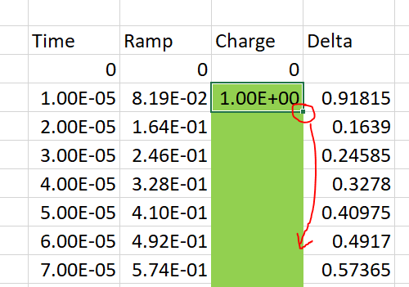

* + Once you have the exponential equation entered correctly, the orange Charge graph will appear in the “Rap and Cap Charging vs. Time” graph and the Delta graph will look different.
* The **Delta** values in column E are the absolute value of the difference between the value in column C and column D – the difference between the line and the exponential function. Adjust the orange cell C4 to minimize the largest delta value. The graph titled “Deviation from a ramp” will help you do this.
* Record the value of Vfinal and the largest value of Delta for your solutions. You will also be asked for your Ramp and Cap Charge vs. Time graph in your solutions.

**Vfinal = 2.23V for which Delta =0.054V**

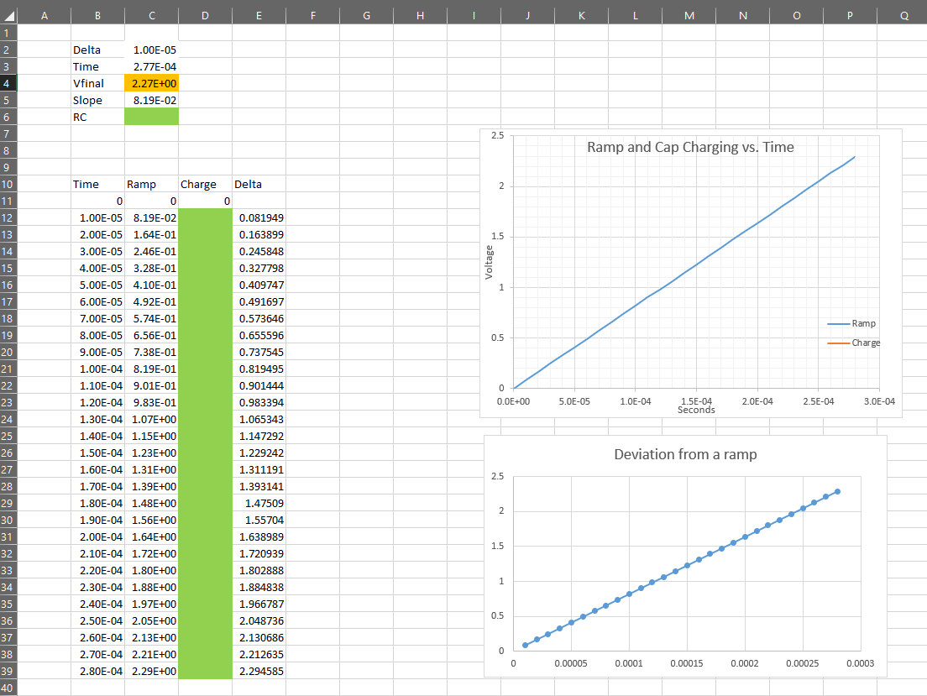

Figure 5: Spreadsheet to compare exponential charging against a straight line.

From the previous work in Excel, you should be fairly confident that the Pseudo Ramp Generator circuit will generate a reasonably straight line. So, let’s simulate it.

**Simulation Pseudo-Ramp Generator**

Use the skills you learned last week to build the circuit shown in Figure 6. You can start by making a copy of the 555-timer circuit from Lab 1, rename the file, and then add the circuit elements in Figure 6.

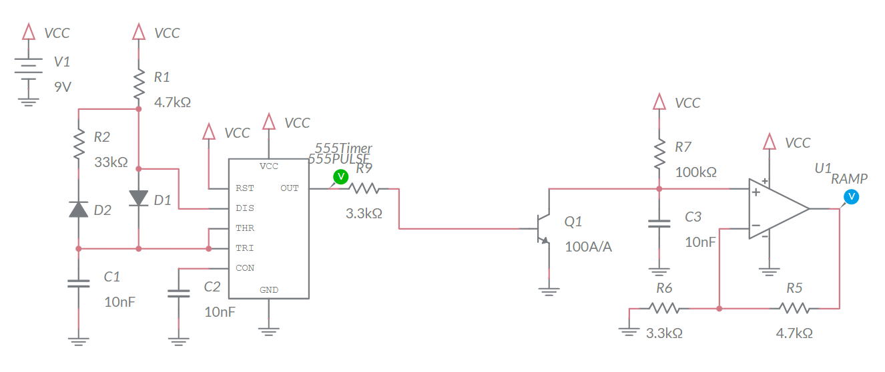

Figure 6: The charging capacitor in the Pseudo Ramp Generator is periodically reset by the 555-timer.

Build the circuit in Figure 6. After building the circuit, run the simulation for 2ms and include the simulated waveform with in your answers. To do this, make sure to Zoom All and use the Export -> Grapher image from the main menu to produce an output graphic.

Enter the highest voltage produced on the RAMP in the Simulation column of Table 2 at the end of the lab.

**Assemble Pseudo Ramp Generator**

This week, you will be soldering in the components in the Pseudo Ramp Generator area of the PCB shown in Figure 7.

For now, do not populate the R21 resistor position. We may use this resistor later to tune the sweep range. More on this later. Be careful to select the correct 10nF capacitor to populate this subsystem. Also be mindful that the transistor Q3 is a polarized part; just make sure that the flat side of the BJT aligns with the flat side of the silk screen outline.

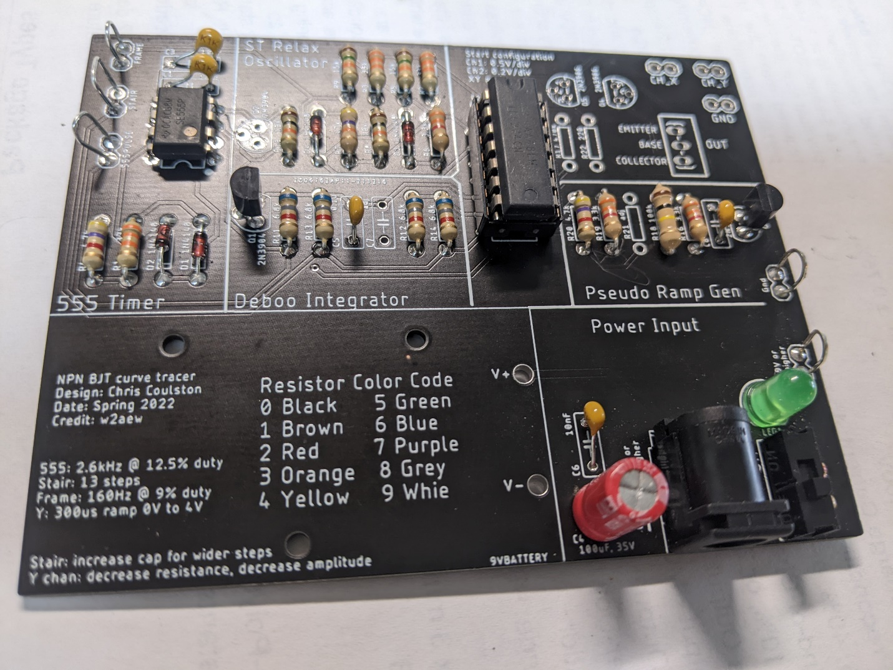

Figure 7: The completed (for lab 4) BJT Curve Tracer board.

After you solder in all the components you should test and correct any problems.

**Test Pseudo Ramp Generator Subsystem**

1. Check the resistance between the “+9V or higher” and “Gnd” test points with the ON/OFF switch in the OFF position. You should get an overload condition on the DMM – there is essentially infinite resistance with the switch in the OFF position.
2. Check the resistance between the “+9V or higher” and “Gnd” test points with the ON/OFF switch in the ON position. This measurement jumps around and may show negative resistance. The value displayed is not meaningful. You should not get a dead short.
3. Power up the BJT curve tracer:
   * Put the ON/OFF switch in the OFF position,
   * Apply power to the board either through your AC/DC converter or using the lab power supply. If you are using the lab power supply, set the voltage to 9V and the current to 100mA,
   * Throw the ON/OFF switch to the ON position,
   * The green LED should illuminate.
4. Power up an oscilloscope, attach a probe to Channel 1 and configure it as follows

|  |  |
| --- | --- |
| Ch1 probe | 555PULSE test point |
| Ch1 ground clip | GND test point |
| Horizontal (scale) | 50us |
| Ch1 (scale) | 1V or 2V (whatever fits better) |
| Ch2 probe | Bottom terminal of unoccupied R21 resistor |
| Ch2 (scale) | Same as Channel 1 |
| Trigger mode | Auto |
| Trigger source | Ch1 |
| Trigger slope | ↑ |
| Trigger level | 4.5V |

1. Set the GND reference of Ch1 and Ch2 to the lowest visible reticule – the waveforms will overlap the same that they did in the MultiSim simulation. Set the horizontal position of the trigger to the left most visible reticule.

After you get everything setup, screen shot the 555PULSE and Pseudo Ramp Generator waveforms and include in your lab report. Use the data collected from the oscilloscope to determine the ramp height; the amount that the Pseudo Ramp Generator voltage increases between 555-timer pulses. Put this value in the Assemble column of Table 2 at the end of the lab.

**Debugging Pseudo Ramp Generator Subsystem**

I would expect most problems with this subsystem to be the result of:

* Bad solder connection
* Wrong component (resistor or capacitor)

If your BJT curve tracer board fails one of the test steps in the previous section, here is some guidance on what may have happened and how you can correct it.

1. If you are getting low resistance with the ON/OFF switch in the off position:
   * Make sure the ON/OFF switch is in the OFF position,
   * Make sure you are reading the DMM correctly.
2. If you are getting a different resistance with the ON/OFF switch in the on position:
   * Make sure the ON/OFF switch is in the ON position,
   * Make sure you are reading the DMM correctly. The reading when the ON/OFF switch in the ON position will jump around a lot and probably be negative.
3. If the green LED does not illuminate when power is applied ad the ON/OFF switch\ is in the on position:
   * Test that you are applying power. Put a DMM in voltage mode and check the +9V and Gnd test points.
   * Check for solder bridges on the read of the PCB.
4. If you are not getting waveforms that look like the MultiSim Live simulation.
   * Check that the board is powered up.
   * Check that the oscilloscope leads are fully inserted.
   * Press the “Default Setup’” button to undo any weird configuration that the last user may have left the oscilloscope in.
   * Check that solder connections by trying to wiggle each component. There should be no visible movement.

# Turn in:

Make a record of your response to numbered items below and turn them in a single copy as your team’s solution on Canvas using the instructions posted there. Include the names of both team members at the top of your solutions. Use complete English sentences to introduce what each of the following listed items (below) is and how it was derived.

**Analysis Pseudo Ramp Generator**

Steps 1 – 3 of analysis

**Analysis Pseudo Ramp Generator in BJT Curve Tracer**

Steps 1 – 7 of analysis

Ramp and Cap Charge vs. Time graph from Excel

Value of Vfinal and the largest value of Delta

**Simulation Pseudo Ramp Generator**

Schematic (use Export -> Schematic Image)

Timing diagram (use Export -> Grapher Image)

**Assemble Pseudo Ramp Generator**

Screen shot oscilloscope output for 555PULSE and RAMP.

Table : Summary of the voltage produced by the Pseudo Ramp Generator.

|  |  |  |  |
| --- | --- | --- | --- |
| Quantity | Analysis | Simulation | Assemble |
| Ramp Amplitude |  |  |  |